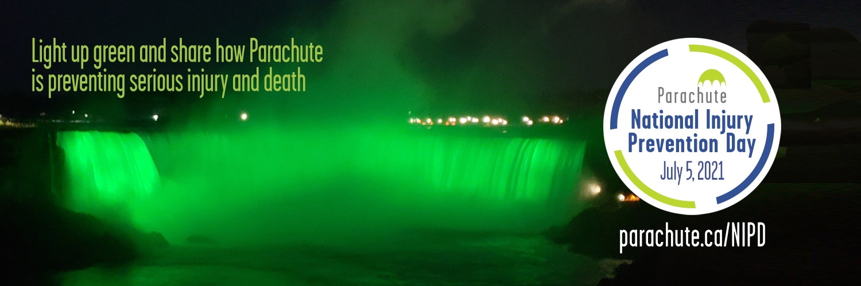

Social Media Guide #ParachuteNIPD 2021

This guide is to help communities and partners use social media to support and promote Parachute’s National Injury Prevention Day.

Who is this guide for?
This guide is for all community leaders and partners who use social media tools or online communication media in a professional capacity, including, but not limited to, the following: Facebook, Twitter, Instagram, LinkedIn, YouTube, or blogs.

Use Hashtags!
Use hashtags in all social media channels in order for us to gain momentum and build a community of support leading up to July 5th, during, and after.

Primary Hashtag: #ParachuteNIPD Secondary Hashtag: #TurnSafetyOn

You can also create your own hashtags, but we urge you to use #ParachuteNIPD in all posts.

How do we engage?
Follow us and comment, share, like and re-post relevant content. We’ll be doing the same, with as many of you as possible, leading up to, during and after #ParachuteNIPD!

When should we start posting?
Start posting and tweeting about #ParachuteNIPD any time! We want to boost the number of people who are aware of Parachute’s National Injury Prevention Day and start engaging your community partners and the public as soon as possible.
Other content ideas: Quotes from your community leaders (e.g., Mayor, Safe Community, local emergency worker)

Sample Tweets
Below are some sample Tweets that you can use on your channels. You’re also welcome and encouraged to come up with your own tweets and messages that make most sense for your organization and your community. Please note that tweet can only be 280 characters in length. You can also tweet out references to your own related materials and website at your organization connect. The images used can be downloaded at parachute.ca/costofinjurygraphics

Before the date of #ParachuteNIPD

DYK that injury is the #1 cause of death of Canadians ages 1 to 44? Or that injury costs the Canadian economy $29.4 billion a year? Learn more about #ParachuteNIPD at www.parachute.ca/nipd & spread the word about injury prevention | 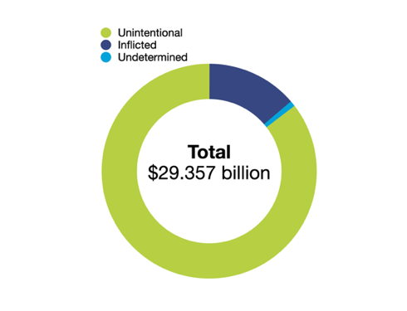
Preventable injury kills more Canadian children than any disease, and more youth than all other causes combined. On July 5, 2021, landmarks across Canada will be lit up in Parachute green to support #ParachuteNIPD! More: www.parachute.ca/nipd | 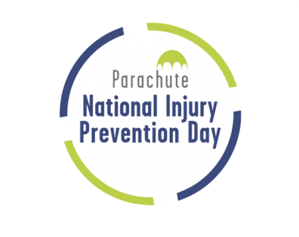
Participate in #ParachuteNIPD on July 5, 2021 to shine the light on predictable and preventable injuries! #TurnSafetyOn www.parachute.ca/nipd

Join the conversation using #ParachuteNIPD and #TurnSafetyOn to help us spread the word about injury prevention. Learn more at www.parachute.ca/nipd | 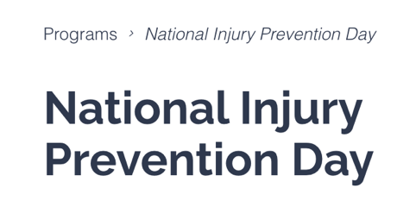
On July 5, 2021, major landmarks across Canada will be lit up in Parachute green to support National Injury Prevention Day! #ParachuteNIPD #TurnSafetyOn www.parachute.ca/nipd

Most injuries are predictable and preventable: We need your help spreading our information on preventing serious injuries on the road, at home and at play. Learn more www.parachute.ca/nipd & join the conversation using #ParachuteNIPD

On July 5, 2021 - #ParachuteNIPD

Potential Lost, Potential for Change: The Cost of Injury in Canada 2021 report has been released. Learn what injuries cost Canadian society: www.parachute.ca/costofinjury #CostOfInjury2021 #ParachuteNIPD | 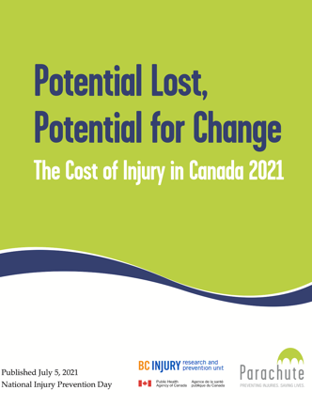
Injuries cost the Canadian economy $29.4 billion a year. The cost of pain and suffering to individuals, families and communities is immeasurable. Learn more at www.parachute.ca/costofinjury #CostOfInjury2021 #ParachuteNIPD | 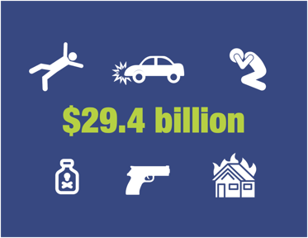
Injury costs $29.4 billion and more than 17,000 lives a year. We have the potential to change the story. Learn more: www.parachute.ca/costofinjury #CostOfInjury2021 #ParachuteNIPD | 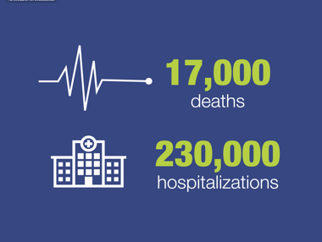
Injuries among children (ages 0-14) cost the Canadian economy $2.9 billion in 2018. Learn more at www.parachute.ca/costofinjury #CostOfInjury2021 #ParachuteNIPD | 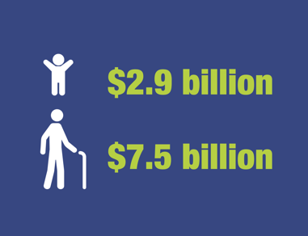
Falls and transport incidents had the highest total costs of any injury cause in 2018 at $13.8 billion, making up almost half of the cost of injury. Learn more at www.parachute.ca #ParachuteNIPD #CostOfInjury2021 | 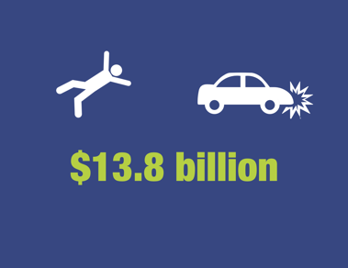
Most of the injuries that occur in Canada are preventable. We must take action to create a Canada free from serious injuries and deaths. Learn how this can be achieved at www.parachute.ca/NIPD #CostOfInjury2021 #ParachuteNIPD | 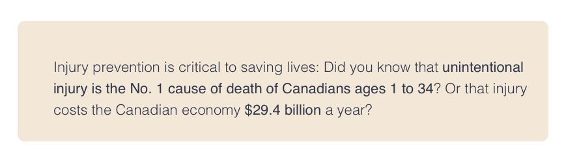
We need to invest in advocacy, proven preventative measures and research to prevent devastating injuries and deaths in Canada. Learn how lives can be saved at www.parachute.ca/NIPD #CostOfInjury2021 #ParachuteNIPD | 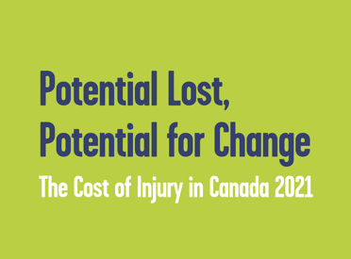
Preventable injury kills more Canadian children than any disease, and more youth than all other causes combined. Every day, 48 Canadians die and 634 are hospitalized because of injuries. Learn more at www.parachute.ca/NIPD #CostofInjury2021 #ParachuteNIPD | 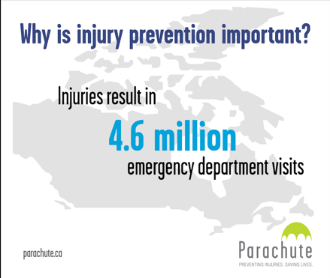
We have made improvements in the area of injury prevention, but there’s still more work to do. Help us spread the message about the importance of injury prevention across Canada. www.parachute.ca/NIPD #TurnSafetyOn #ParachuteNIPD

Post #ParachuteNIPD

#ParachuteNIPD has wrapped up, but #InjuryPrevention is important all year long! Visit @parachutecanada for info & tips: www.parachute.ca #TurnSafetyOn | 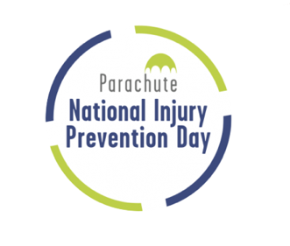

NIPD landmarks

Halifax, NS, Halifax City Hall – @hfxgov Halifax City Hall will light up in Parachute ‘green’ to celebrate National Injury Prevention Day 2021! #ParachuteNIPD #TurnSafetyOn

Toronto, Ontario, 3-D Toronto Sign – @TorontoComms (City of Toronto) Toronto Sign shines Parachute ‘green’ for National Injury Prevention Day #ParachuteNIPD.
Let’s reach an injury-free Canada! #ParachuteNIPD #TurnSafetyOn

Niagara Falls, ON, Niagara Falls – @NiagaraFalls (Niagara Falls Canada) Niagara Falls lights up Parachute ‘green’ in honour of National Injury Prevention Day! Help spread the word! #ParachuteNIPD #TurnSafetyOn

Vancouver, BC, Vancouver City Hall – @CityofVancouver (City of Vancouver) Vancouver City Hall celebrates National Injury Prevention Day by shining Parachute ‘green’. Let’s stop preventable injuries! #ParachuteNIPD #TurnSafetyOn

Kingston, Ontario, Kingston City Hall – @cityofkingston (City of Kingston) Kingston City Hall will light up Parachute ‘green’ to celebrate National Injury Prevention Day! #ParachuteNIPD #TurnSafetyOn

Vancouver, BC, Science World at TELUS World of Science – @scienceworldca Science World lights up Parachute ‘green’ to honour National Injury Prevention Day. Let’s raise awareness on injury prevention! #ParachuteNIPD #TurnSafetyOn

Legislature Assembly of New Brunswick, Fredericton - Legislature Assembly of New Brunswick will light up in Parachute ‘green’ to celebrate National Injury Prevention Day! #ParachuteNIPD #TurnSafetyOn

St. John’s City Hall, St. John’s - St. John’s City Hall lights up Parachute ‘green’ in honour of National Injury Prevention Day! Help spread the word! #ParachuteNIPD #TurnSafetyOn

For the full list of landmarks go to www.parachute.ca/lightupcanada

Images
While we haven’t used any images in these sample posts, we encourage you take photos of the Canadian landmarks lit up and share them in your posts. Link to the #ParachuteNIPD 2021 image gallery: www.parachute.ca/lightupcanada

Ask Our Advice

If you have any questions or need some guidance, please feel free to direct them to Margarita at socialmedia@parachute.ca

