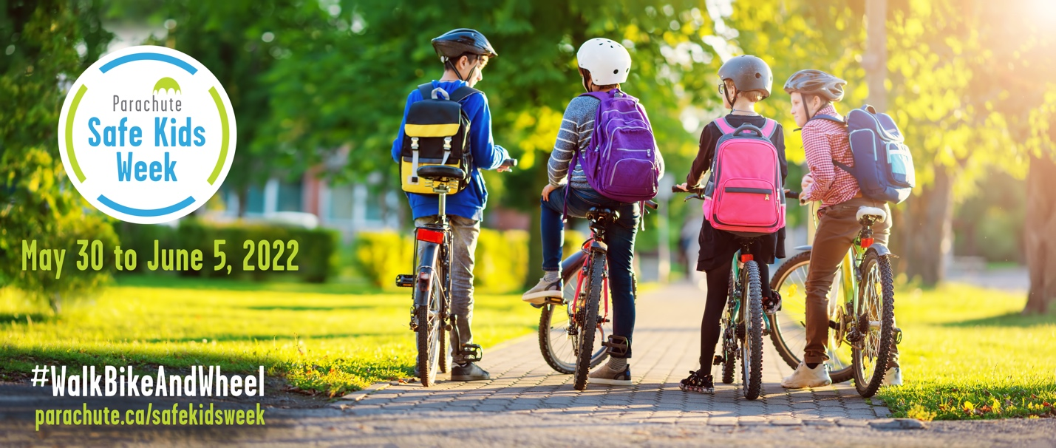
Backgrounder: Parachute Safe Kids Week
May 30 to June 5, 2022

Parachute Safe Kids Week is an annual awareness campaign designed to bring attention to predictable and preventable injuries in children.

In 2022, Parachute celebrates its 10th Anniversary and Safe Kids Week will focus on promoting safe and active transportation: #WalkBikeAndWheel.

Each year, an average of 1,078 children in Canada under age 15 are injured as pedestrians and another 570 are injured as cyclists in collisions with motor vehicles.

Vision Zero is a road safety framework that aims to decrease these numbers to zero fatalities or serious injuries on our roads, with a focus on designing safer road systems for everyone to use. As jurisdictions and organizations across Canada, including Parachute, adopt the Vision Zero approach, it’s important to keep a focus on our most vulnerable road users. Even one child killed or seriously injured on our roads is unacceptable.

This year’s Safe Kids Week theme encourages children and families to stay active and keep themselves and their loved ones safe on their travels to and from school to the bus stop and around their community.

Keeping our roads safe is a shared responsibility. We encourage drivers, communities, municipalities and other levels of government to support children and their families in creating environments that can help them engage in active and safe transportation.

For more information, visit
parachute.ca/safekidsweek.

